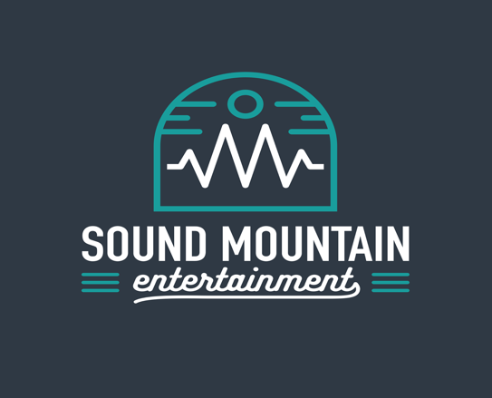

Sound Mountain Entertainment
Wedding Information Submission

Congratulations!
Thank you for choosing Sound Mountain Entertainment. Please be as detailed as you can in this form. Not every question may apply, but please take special note of important names to announce (both first and last if applicable), schedules, song lists and any other pertinent information.
We appreciate your business and feel honored to be apart of such a momentous occasion. Please do not hesitate to call or email with any questions.
Sincerely,
Peyton Thomas (360) 441-5200
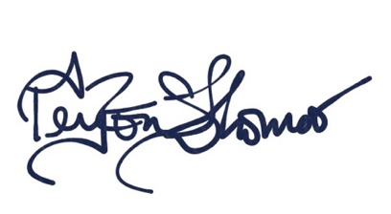
720-580-1200
Soundmountainent.com
info@soundmountainent.com

Name and role (if applicable):

Bride and Groom’s Name:

Date of Your Event:
Time Event Starts:
Time Event Ends:
Location/Address of Event:
Name of Bride's Parent(s):
Name of Groom's Parent(s):
Maid/Matron of Honor:
Best Man:
Other Key Players:

Best Contact Number:
Wedding or "Day Of" Coordinator Name & Number:
Approximate Number of Guests:
Wedding Theme, Colors, etc:
Any Special DJ/MC Dress CodeNotes– Colors, Themes or Styles: (Typically wear black slacks, shirt and tie).
Ceremony Information
If we are providing audio at your ceremony, please complete the following questions. If not, you may skip to the next section.
What kind of background music do you want as your guests arrive or are being seated:
Song for seating of the parents/grandparents:
Song for Groom Entrance:
Song for Wedding Party Entrance:
Song for Bride Entrance:
Any other event during ceremony that needs music:
Exit Music:
Reception Information
What kind of dinner/background music:
Grand Entrance Music:
Name you would like to be called during Grand Entrance:
First Dance Song:
Father Bride/Groom Dance Song:
Mother Bride/Groom DanceSong:
Any other special dances or performances:

We will have the following at our reception (indicate all that apply):
Cake Cutting, Bouquet Toss, Garter Toss, Wedding Games, Other
If other, please explain:
We like to dance to the following types of music (indicate all that apply):
50s, 60s, 70s, 80s, 90s, Top 40, Country, Other
If other, please explain:

Comments or Specific Song Requests:

